TECHNICAL
SPECIFICATION
&
INFORMATION

Technical Department
Kenton Theatre
New Street
Henley-on-Thames
Oxfordshire RG9 2BP

Technical Manager
technical@kentontheatre.co.uk

Cliff Colborne
Updated December 2019

CONTENTS

1: Stage Dimensions
2: Stage Suspensions
3: Stage Equipment
4: Stage Lighting
5: Sound
6: Communications
7: Power Supplies
8: Loading Access
9: Accommodation
Auditorium
Dressing rooms
Orchestra Pit
10: Miscellaneous Information
11: Grid Plan
12: Floor Plan
1. STAGE DIMENSIONS
Proscenium Width | 7.62m | (25’)
Proscenium Height | 4.57m | (15’)
Normal Masking Height | approx. 4.00m | (13’)
Height to underside of Grid | 10.15m | (33’)
Depth of Stage (from edge of orchestra pit to cyclorama wall) | 5.49m | (18’)
Apron over orchestra pit (removable 5 individual sections) | 1.23m | (4’)
Wings Width SR (from Pros. Line) | 2.13m | (7’)
Wings Width SL (from Pros. Line. Max height 2.4m (8’) | 2.00m | (6’6”)
NOTES:
Auditorium Steps cannot be removed, but stage-level tops and fronts are available if required.

An additional Apron Extension of 0.76m (2’6”), also forming a catwalk when the orchestra pit is open, is available by prior arrangement only at the time of booking, as this will require the removal of Row A and withdrawal of tickets for this row of 13 seats before they go on sale.

For safety reasons and the avoidance of damage to seats, the removal and replacement of apron, extension and seats must only be carried out by, or under direct supervision by, Kenton Technical Staff. This requires two people for two hours to build and again to restore, and will incur a charge of £195 + VAT to be done prior to your arrival, or – if at the start and end of your booking period and you can provide two people to help, £125 + VAT per.

The Stage floor is a general-purpose surface, painted black. Should you wish to change this colour then you must cover the floor with either a pre-painted stage cloth or sheets of hardboard, taped at all joins and painted as required, and removed during getout.
It is not offered as suitable for dancing. To avoid damage to dance shoes or costumes, you are strongly advised to bring a portable dance floor. We do not supply this, but can arrange to hire-in at your expense.

Gaffer Tape, nails, staples, tacks and screws must not be used on or in the stage floor. PVC tape may be used for setting marks provided it is fully removed afterwards. Cables which must be run at floor level must be laid tidily, covered by cable protectors, and marked with PVC if necessary.
The Cyclorama Wall is painted pale grey. Please avoid marking it in any way. Do not lean against it or allow ladders or scenery to do so. Any damage or marks will be charged for. If marked, do not attempt to touch it up.

2. STAGE SUSPENSION

3-Line system comprising:-

16 hemp line sets. Max 75kg per bar dead weight (no counterweights), two with tab tracks, the remainder with standard 48mm bars. Of these three have attached Swivel bars for side masking legs and three normally have borders. All bars are attached by shackles for ease of interchanging. Do not untie them.

4 x Lighting Bars. Max loading 150kg (0.70 ton), on steel wire, with self sustaining hand-operated winches.

The Safety Curtain inside proscenium with controls Stage Right is no longer a legal requirement. It has been disabled, and operation it must not be attempted under any circumstances.

House Tabs upstage of safety curtain on fixed track with hand-operated winch Stage Right.

House Border immediately upstage of tabs.

Festoon Curtain approx. 0.8m (2’9”) upstage of tabs. Motorised, with control Stage Right and in lighting control room FOH.

3. STAGE EQUIPMENT

Curtains:

1 x pair Main House Tabs red | On fixed track | Hand-winch control SR
1 x matching Border | Fixed position | Flown, winch on fly gallery
1 x pair black Travellers | On flown track | Cord operated from SR
1 x pair red Travellers | On flown track | Cord operated from SR
3 x pairs black Legs | On swivel bars | Fixed to fly bars
3 x black Borders | On fly bars
1 x gold Festoon Curtain | Fixed position | Motorized, duplicate controls SR and in Control Room
WARNING! Check that you can handle the weight on a flyline set before releasing it and get help if necessary.
Tie off securely with a round turn, then at least two figure 8s and finish with a half hitch.
Our Technician will demonstrate this on get-in if necessary and there is a photo instruction notice on the fly gallery.

NOTES
1. To release leg swivel bars, pull down on adjusting sash cord, NOT on the curtains.
Ensure swivels are parallel to the bar before raising or lowering. Before flying completely out, tie swivels to the bar to prevent unwanted movement.
2. Should it be necessary for you to remove drapes from bars, please keep the face side off the floor and ensure that they are folded face-inside and stored in a clean, dry place (not the paint shop!). They must be replaced on get-out unless previously agreed otherwise with the Technical Manager.

Braces and Stage weights

20 stage braces varying in length from 1.5m to 3m extended located in rear corridor.
17 stage weights located in the wings DL and DR.

Backcloth tensioners

12 x 3m (9’) steel conduit lengths and 4 x 2m (6’6”) lengths with joiners for weighting the bottoms of backcloths stored in rear corridor.

Ladders
 |  |  | IN | OUT
1 | 12-rung extension ladder | NOT to be used FOH or on Cyc
1 | 12-rung Zarges combination ladder | For use in Auditorium
1 | 8-rung Zarges combination ladder | For use Onstage
1 | 6-rung extension ladder | For use in Circle
 | Stored in control room
3 | Various A-frame stepladders
 | All the above stored in rear corridor or paint shop

4. STAGE LIGHTING

FOH POSITIONS
 |  | IN | OUT
FOH LX 1 BAR | 10 channels, 2 patchable 13 amp sockets, DMX socket.
 | 6 x Strand Cantata F: 1kw; 4 x Source4 Junior 25/50: 575w
FOH LX 1 Wall Bars and booms, SL & SR | 7 channels per side  1 x Harmony 22: 1kw; 2 x Cantata 26/44: 1kw; 3 x Prelude F: 500w; 1 x Patt 23/S profile: 500w each side
FOH Centre L & R Wall Bars | Each with 3 x Cantata 18/32: 1kw
FOH LX 2 Bar above Circle | 14 channels, 14 Harmony 15/28, 1kw

STAGE POSITIONS
 |  | IN | OUT
LX 1 Bar | 20 channels. 12 x Prelude F: 500w; 4 x Source 4 Junior Zoom: 520w; 4 x Patt 123: 500w
LX 2 Bar | 10 channels. 4 x Cantata F: 1000w; 6 x Prelude F: 500w
LX 3 Bar | 14 channels. 13 x Patt 743/223: 1kw; 2 x Parcans: CP62 (Paired)
LX 4 Bar | 4 channels to 5 x Coda 4-cell flood units; 4 channels, with 1 x Patt.23 and 1x parcan each end
Booms DL & DR | 3 channels, with 1 x Patt 23/S and 2 x Patt 123 Fresnel: 500w, each side.
Booms CL & CR | With 3 x Parcans: CP 62 each side
16 Stage Level Dips | 4 sockets each DL, DR, UL and UR

PATCHING AND DIMMING CONTROL

120 channels Patched 1/1 but fully patchable in dimmer room and in wings. Strand JTM/STM: 120 circuits @ 2kw (10 amps) per channel. ETC Element 40 lighting control, 250 channel with monitors, mouse and keyboard located in Balcony control room .

DMX POINTS: 1 each in Control Room, Dimmer Room, FOH 1 LX, FOH 2 LX, Stage LX1, high level SR, Stage level DS L and R.

ADDITIONAL / SPARE EQUIPMENT available on pre-request (subject to availability):
Parcans, Floorcans, irises, gobo holders; telescopic stands, 13amp and 15amp extension cables up to 10m; Grelco adaptors.

NOTES:
1. FOH ADVANCE BAR may only be raised or lowered by trained personal authorised during the Get-In.
2. The fixed monitors may not be removed from the control room.
3. To cater for the wide variety of show requirements with the minimum of resetting time, the rig is set up by default as four colour washes plus neutral (L152) and cool (L117) washes covering 9 separate but merged areas; with OVER 30 fixtures rigged but uncommitted, for “specials”. Although obviously adjustments will be required for complex plots we strongly advise working within this setup as far as possible, as alterations and restoration to the default rig must be made in your time or at your expense. If changing colours, please use our spare frames supplied where possible and retain our gells in their frames.
4. Professional Companies should supply their relevant tech. spec. in advance AND contact the Technical Manager to discuss what alterations are necessary.
5. A proportion of spare lamps is supplied. Please handle fixtures gently when adjusting as hot lamps are easily damaged. All blown lamps must be retained for inspection and if mechanically damaged (as opposed to age-failed), or not returned, will be charged for.

5. SOUND

An independent Induction Loop System is installed for the convenience of patrons

Moveable FOH equipment located in the Circle open Control Room.

 |  | IN | OUT
1 | Allen and Heath QU 24 digital sound mixer OR  Soundcraft Spirit Live LX7 MkII mixer: 24- channel, 4 groups, 6 aux
 | OR Soundcraft Spirit Live mixer: 8-channel, 3 groups, 4 aux (as required)
1 | Alesis Midiverb 4 Processor
1 | Denon DCD 615 Stereo CD Player
1 | Sony MDS JE330 Minidisk Player

Stage Amp Rack:
 |  | IN | OUT
1 x | Ampetronic ILD9 Induction Loop Amplifier
1 x | DBX Graphic Equaliser
1 x | Crown Amplifier 540 watts per channel stereo into 8 ohms
1 x | Rane MA 6S 6-channel Amplifier 150 watts per side into 8 ohms
1 x | 100w Yamaha bass amplifier
12-way | Speaker patch panel for Cyc, Balcony and rear Stalls plus 6 onstage sockets.
12-way | Sends/Returns box

Speakers and Speakers Patch

FOH |  |  | IN | OUT
2 x |  | Nexo PS 15: 50 watt speakers into 8 ohms on Proscenium
2 x |  | JBL 15” Bass bins under stage steps
4 x |  | Electro Voice S-40: 60 watt 8 ohms: 1 each rear stalls and rear circle L & R
STAGE
2 pairs |  | Electro-Voice S-40; 120 watts per pair into 8 ohms, on rear wall L& R. 6 channels at stage level: 3 DL, 3 DR, each with XLR 3 and Speakon sockets.
4 x MIC INPUTS |  | Dynacord AXM 12 power monitors.  48: SL 1-16; Orch Pit 17-32; SR 33-48, to sound desk position.
SENDS/ RETURNS |  | 12: FROM Control Room
Other equipment (issued only if pre-arranged)
6 | Vocal microphones (SM 58 type)
3 | Stands with boom extensions
3 | Straight weighted-based stands
4 | Vocal Radio Mics, Sennheiser SKM 100 system
4 | Tie Clip Radio Mics, Sennheiser ME2 with belt packs
4 | IMG Stageline passive DI boxes
 | Various XLR3 cable lengths, adaptors and converters

6. COMMUNICATIONS

Tech Pro Ring Intercom
(a) | Performance sound relay to all dressing rooms and control room
(b) | Stage Manager interrupt for show calls as above
(c) | Six x comms packs and seven x headsets on open ring communication between SM, Sound and Lighting desks, plus Wings Stage Left and Right, Fly Gallery and Orchestra pit, issued as required.
Telephone | Between prompt desk, Control Room and Foyer (FOH Manager)

Video relay to Stage Manager’s desk

7. HOT POWER SUPPLIES

Stage and FOH 13amp ring mains
2 x | Double sockets stage left/stage right
2 x | Double sockets SM’s desk stage right
6 x | Double sockets in Orchestra pit
2 x | Double sockets +8 way mains filter Balcony Sound Desk

The following supplies are located in the dimmer room:
1 x | 16 amp CEE form socket (3 phase) protected by 16 amp MCCB
1 x | 32 amp CEE form socket (3 phase) protected by 32 amp MCCB
Connection to these supplies will only be permitted once evidence of current Electrical Safety is proven. Connection will be made by Kenton Technical Staff only.

8. LOADING ACCESS
New Street is one-way. The Kenton is about 50m down on the left with Residents’ Only parking immediately outside and Pay & Display (max 2 hrs, free and unlimited after 6pm and Sundays) elsewhere. Large vehicles park on double yellow lines before the Theatre while loading before relocating to long stay car park at the Station. Cars and small vans may alternatively relocate to Kings Road Pay & Display (max 3 hours but free and unlimited 5pm – 10AM and all day Sunday).

Entrance is through a large, single door 266cm high (at the apex of an arch on top of the door) and 89cm wide.

9. ACCOMMODATION
Auditorium Seating Capacity | 240
Stalls | 185
Balcony (*with/without sound desk outside control room) | 49 / 55*
Back Stage | 100
No standing allowed in auditorium
Wheelchair access available | Max. 2

Dessing Room | Maximum Capacity |  | IN | OUT
Ground Floor Dressing Rooms
Dressing Room 1 | 15 | with iron and ironing board
Dressing Room 2 / Crew Room | 6 | with kettle, fridge, and mugs
First Floor Dressing Rooms
Dressing Room 3 | 25 | with iron and ironing board
Dressing Room 4 | 14
Orchestra Pit | 10* | 10 lighted music stands. 10 padded armless chairs.
10. MISCELLANEOUS INFORMATION
Insurance and Performance Licence.
The Company Stage Manager or representative must produce a valid certificate of Third Party Liability at or before the time of get-in for display on the backstage notice board.

Production Crew: We will only provide such crew as are included within the costs detailed in our contract with you.
A simple hire contract does not normally include technical staff or crew, unless we have entered into a contract to do so and agreed the extra costs at the time of booking. The current hourly rate per person is £18. Otherwise, you must provide at least a Stage Manager and a Lighting Rigger/Operator, plus such extras as your show may demand (eg. Sound operator, stage hands, flymen).
Where the Theatre is being fully handed over to a Company, on get-in, our Technician will complete a check list with the Company Stage Manager or other responsible representative to ensure that all appropriate information is given, including evacuation procedures, security and safety requirements; and to document the inventory and condition of the facilities and equipment. This must be agreed and signed off by both parties. This procedure will be repeated on get-out.
Brief instruction will be given as required on the operation of the Kenton facilities, equipment and procedures. We are not able to provide comprehensive technical training for complete novices. Should our Technician consider that you do not have sufficient competent personnel to operate safely or to an acceptable artistic standard, we reserve the right to put in place the necessary number of Technicians at your expense. If we have to involve outside contractors, the hourly rate they charge may vary considerably.

Front of House staffing is by trained Kenton Volunteers. Our duty FOH Manager has overall responsibility for safety, clearance to start the show and observance of licence provisions.

Safety
We do not provide any PPE for Production Company personnel. The Visiting Company is responsible for the provision of all relevant safety training, supervision and PPE for its own staff (eg. Hard hats, safety shoes, ladder safety, First Aid, risk assessments/method statements etc. where applicable).

Our Technician will advise on the location of First Aid Boxes, Fire Extinguishers and alarm points, and emergency evacuation procedures, but the Production Company’s Stage Manager has total responsibility for backstage security and the company’s safety and conduct while in residence.

No electrical equipment may be brought into the Kenton unless it bears a currently valid readable PAT label (or bar-code label supported by printed documentation).

The Kenton Theatre Management reserves the right at any time to enter any part of the building and to supervise or inspect the use of all equipment (including hired equipment), construction and materials to ensure compliance with Fire, Health and Safety Regulations.

SMOKING AND VAPEING ARE PROHIBITED ANYWHERE IN OR AROUND THE THEATRE

No flammable materials may be brought onto the premises unless effectively fireproofed, including straw, bulk newspapers, cardboard, etc and costumes.

No naked flames may be used onstage including lighted cigarettes.

Pyrotechnics: We will only allow Sky-high or Le Maitre Pyrotechnic systems within the building
IMPORTANT: It is vital to inform the Technical Manager or FOH Manager if pyros are to be used so that the relevant smoke detectors can be disabled.

Users are forbidden to access the Stage Grid or any Loft space for any purpose. If access is essential, contact our Technical staff.

The paintshop at the rear of the Theatre may be used if available by the Company whilst in residence, provided it is left as clean and tidy as possible on get-out.

Staging materials stored within the premises do not necessarily belong to the Theatre. Permission to use any items should be arranged through the Technical Manager.

Your staging materials, costumes, props, furniture and other items must be removed from the premises on get-out unless contrary arrangements have been agreed with the Technical Manager in advance. This includes construction and production waste such as timber and scenic materials. These must not be dumped in the paint shop or rear yard, nor placed in the wheely bins, which are intended for general litter-type waste and recycling.

We will endeavour to maintain the Theatre and its equipment as shown in this Specification, but all equipment on this specification is subject to availability. In case of equipment failure or other circumstances beyond our immediate control, we reserve the right to substitute any equipment without prior notice.

The Kenton Theatre Management. September 2019

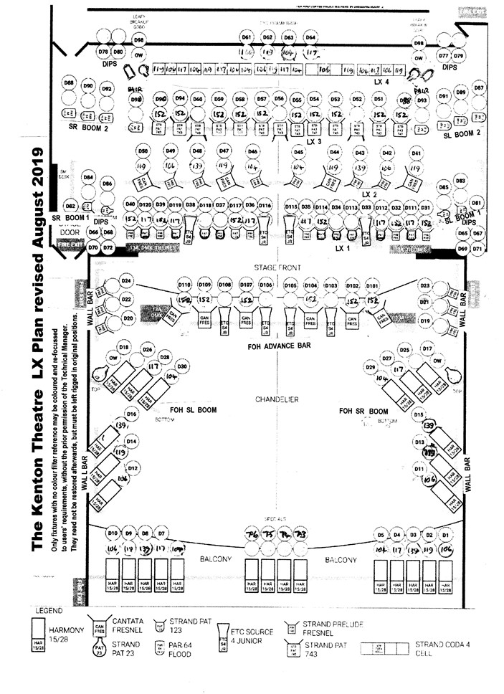
DEFAULT HANGING PLOT AND GRIDPLAN
From Cyc | Bar No. | Cloth No. | Cloth Description | Bar No. | From Pros. | IN | OUT
0 |  |  | Cylorama Wall |  | 18’
0’ 6” | 16 |  |  | 16 | 17’ 6”
1’ 0” | 15 |  | Full Black Travellers | 15 | 17’ 0”
1’ 6” | 14 |  |  | 14 | 16’ 6”
2’ 0” | 13 |  |  | 13 | 16’ 0”
2’ 6” | 12 |  |  | 12 | 15’ 5”
3’ 0” | 11 |  | Black Legs 6’ 0” x 16’ 0” | 11 | 15’ 0”
3’ 6” | 10 |  |  | 10
LX4
5’ 5” | 9 |  | Pleated Black Border 4’ 0” x 30’ 0” | 9 | 12’ 6”
6’ 0” | 8 |  | Red Velour Travellers 17’ 0” x 30’ 0” | 8 | 12’ 0”
6’ 5” | 7 |  |  | 7 | 11’ 6”
7’ 0” | 6 |  | Black Border 4’ 0” x 30’ 0” | 6 | 11’ 0”
LX3
10’ 0” | 5 |  | Black Flat border 5’ 0” x 30’ 0” | 5 | 8’ 0”
11’ 0” | 4 |  |  | 4
LX2
12’ 5” | 3 |  | Black Legs 6’ 0” x 30’ 0” | 3 | 5’ 5”
13’ 0” | 2 |  | Black Border 4’ 0” x 30’ 0” | 2 | 5’ 0”
GOLD FESTOON CURTAIN
LX1
6’ 6” | 1 |  |  | 1 | 1’ 6”
17’ 0” |  |  | Main Red Border |  | 0’ 6”
18’ 0” |  |  | Main Red Tabs |  | 0’ 0”
PROCENIUM ARCH
Note: You are free to move the leg and traveller bars as complete units to suit your production requirements, but they must be returned to their original position at the end of your booking to avoid any additional charges to your Company. Swivel leg brackets are not to be removed from the bars.
FLY FLOOR

Wings 3.07m
Height to UNDER FLY FLOOR 2.46m (8’ 0”)
SL EXIT TO
DRESSING ROOMS

10m (30’)
18’ 0”

Black legs
FIRE EXIT

Curtain Line

GROUND FLOOR DRESSING ROOMS

Cyclorama wall

5.5m
1.2m (4’)

7.69m (25’)

Covered Orchestra Pit

FIRE EXIT

Black legs

TO DRESSING ROOMS
AND TOILETS
STAGE DOOR
(ONLY GET-IN ACCESS)

